UKCA Declaration of Conformity

Instrument:
Product: Tape Measures – Short & Long
Type: Class I / Class II
Batch: Year 2022

Manufacturer:
Name: Fisco Tools Limited
Address: 21 Brook Road, Rayleigh Essex. SS6 7XD United Kingdom

The DoC is issued under the sole responsibility of the manufacturer:
Name: Fisco Tools Limited
Address: 21 Brook Road, Rayleigh, Essex. SS6 7XD United Kingdom

Object of the declaration:
Short Tape Measures - 2M to 10M in length applicable to metric scale.
Long Tape Measures – 15M to 100M in length applicable to metric scale.

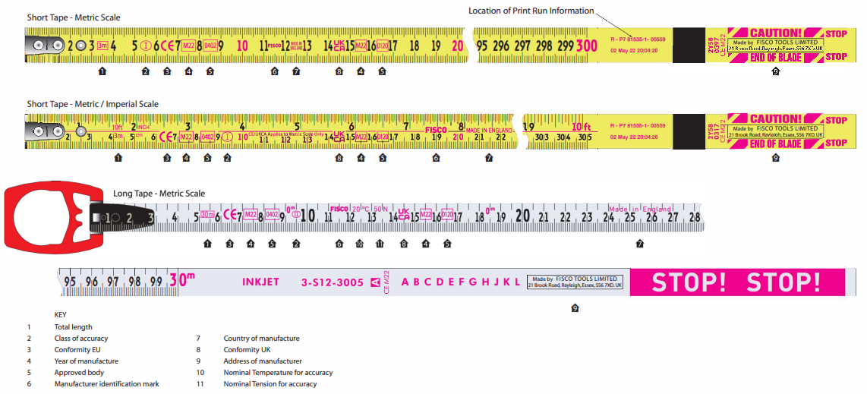
The object of the declaration described above is in conformity with:
The Measuring Instruments Regulations 2016 (as amended) S.I. 2016 No. 1153, Schedule 1B, Module H. Manufacture of Material measures of length, Schedule1B, Chapter I, for the instruments defined within the technical documentation retained by the manufacturer and copied to the Approved Body.

UKCA Declaration of Conformity

The approved body SGS (0120) performed an assessment of Fisco Tools Quality Management System and verification procedures in respect of:

Measuring Instruments Regulations 2016 (as amended) S.I. 2016 No. 1153, Schedule 1B,
Module H: Conformity based on full quality assurance and issued the certificate:

Certificate No. : GB/MIR0025

Mark, Approved body no. 0120, and Year M22 identify conforming product applicable to this declaration.

On behalf of Fisco Tools Limited

Name: Gary Beadon Title: Managing Director

Place: United Kingdom Date: 1st May 2022

